AUBG Emergency App – Android Project



Nikolay Zahariev

Ivan Martinez Pavon

We have successfully completed all the project and also we have included some extra features.

The extra features that we have included are the GPS features mentioned in the project description. GPS location when Emergency button is pressed in order to send the location in the message. And also the Campus Emergency Map, button placed in Get Help activity, that opens a map activity with the safe points in campus and main building.

*We hereby declare that the submitted project software is all our own work. We did not copy any software from anyone else or anywhere else. No one but us developed the project software”*

*We also declare that the contribution declared for each group member in this report is truthful and correct.*

Nikolay Zahariev

Ivan Martinez Pavon

# **Project overview:**

The function of the application is to provide integrated emergency and student support service information and assistance to all AUBG users.

**Features**

When the app icon is tapped, the user sees

1. ***“Emergency” button***

Functionality: Send the user’s name, information, and GPS location in the form of a text message to an emergency phone number (e.g. on-call Security). The button is of type tap-and-hold.

1. *“****Get Help” button***

Functionality: when tapped transfers the user to the “Get Help” screen.

**Get Help Screen**

Contains set of “Get Help” buttons

Functionality: Provides guidance for people in, or witnessing, a dangerous situation to contact appropriate assistance and (possibly) diffuse situation until help arrives.

Upon opening, top of screen prompts “I Can See…” and navigation buttons to new screens

1. “Threat of Violence”

2. “Weapon on Campus”

3. “Campus Emergency Map”

Each of first two buttons above navigates to individual screen providing

1. Appropriate assistance contact for AUBG (by name and photo); tap to navigate to…

• Type of assistance provided

• AUBG office location (and hours, if applicable)

• One-touch contact via AUBG phone number

2. Possible suggestions of ways to monitor, assist, and/or diffuse situation until help arrives.

3. “How do I know?” followed by brief, bullet-pointed description

**Campus Emergency Map Screen**

Functionality: Direct users to designated safe points in event of campus-wide emergency.

Opens map of campus (Skaptopara Campus and Main Building) with locations of designated.

E.g. emergency gathering points (as in the case of fire)

Taps into GPS to show user location on map

# **Work distribution:**

We decided to do the project following the pair programming way. While one of us was writing the code, the other was there looking and reviewing each line of code as it was typed in. We both were changing after a while but basically we split the work in Java programming and User Interface. Nikolay was the one in charge of Java code and Ivan was in charge of the User Interface.

# **Screenshots**

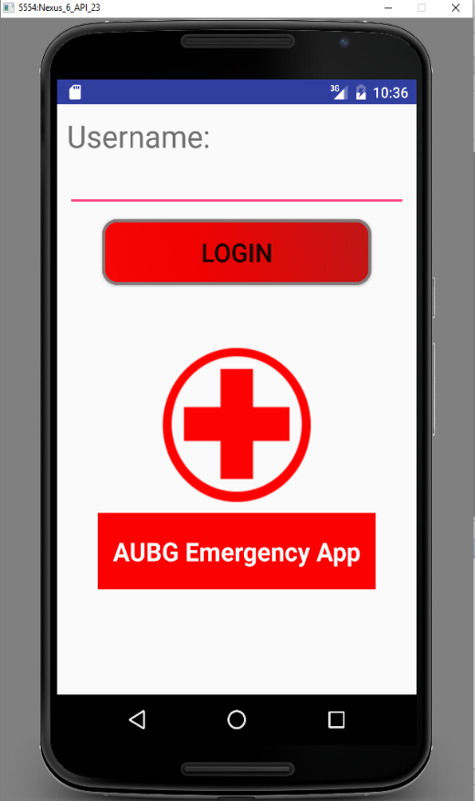First screen we see when launch the app is Login Activity, it ask for a name that will be used later to send the emergency message. If we did the login in advance, the session will keep our name and this activity will be skipped, we will see directly the Main Activity.

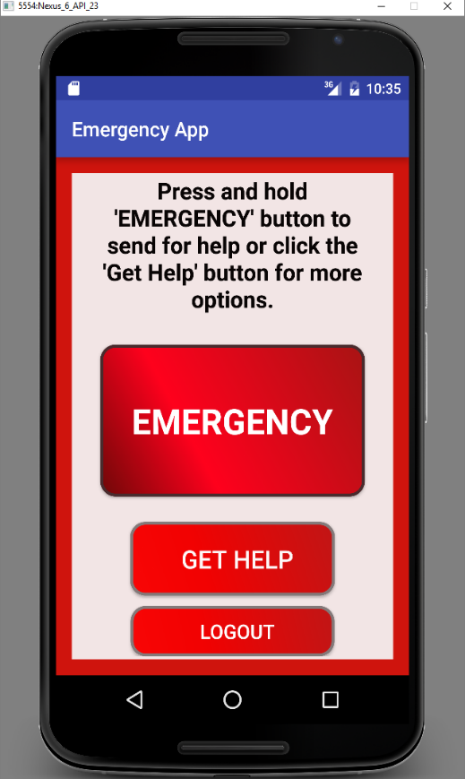

After login, we see the Main Activity. It shows a label explaining how to use the EMERGENCY button in red. The button is used holding the tap for a while and the emergency message will be sent. After that, we see “get help” button that will raise get help activity, and at the bottom, a button to logout of the session. It will clean the session, removing the user name, and launch again the Login Activity.

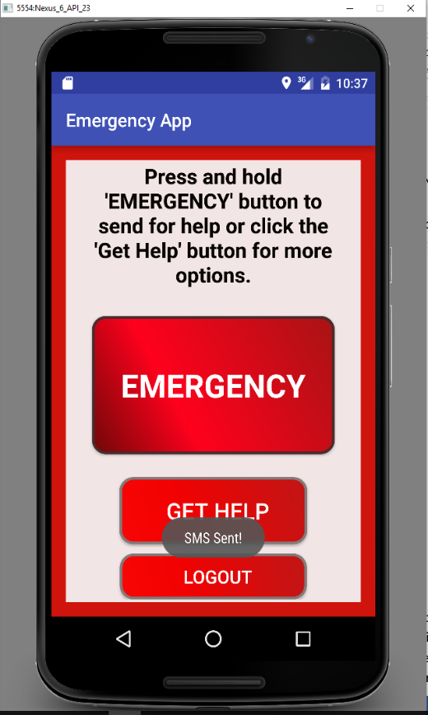

If we hold the EMERGENCY button, an emergency message will be sent with our name and our location and we will know it because a toast will appear in the screen noticing us.

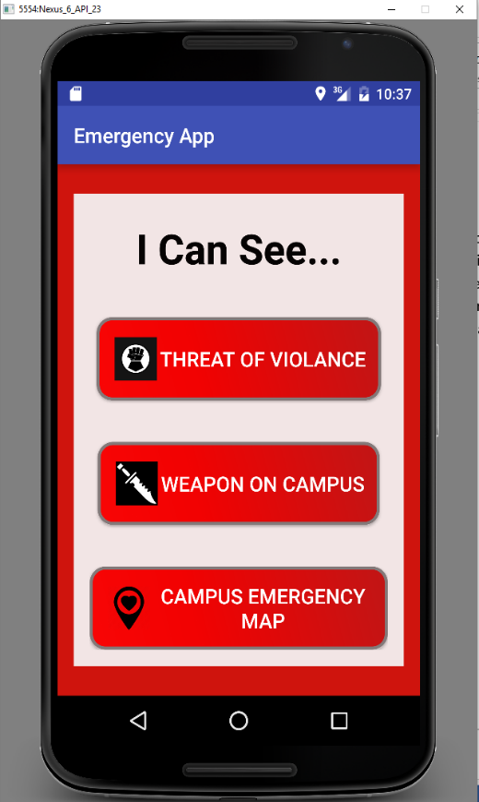

If in the main activity we press the button with the label “get help”, this activity will be raised, In it we can see three buttons, one for information about threat of violence, one for information in case we see a weapon in campus and the last one for a campus emergency map.

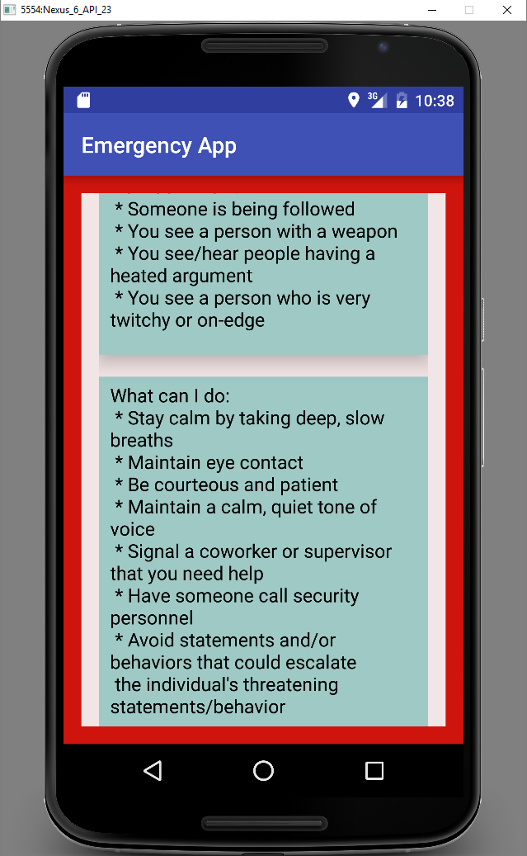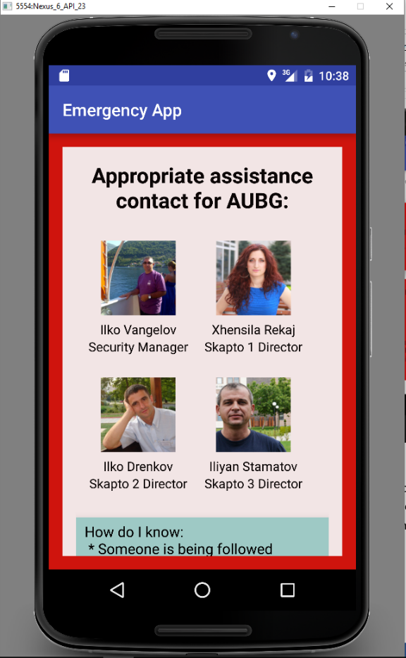

When threat of violence is pressed, it opens a view for contacting with AUBG staff, security manager and directors of residences. A section “How do I know?” with explanation for knowing if you are witnessing threat of violence. And it also shows possible suggestions of ways to monitor, assist and diffuse the situation until help arrives.

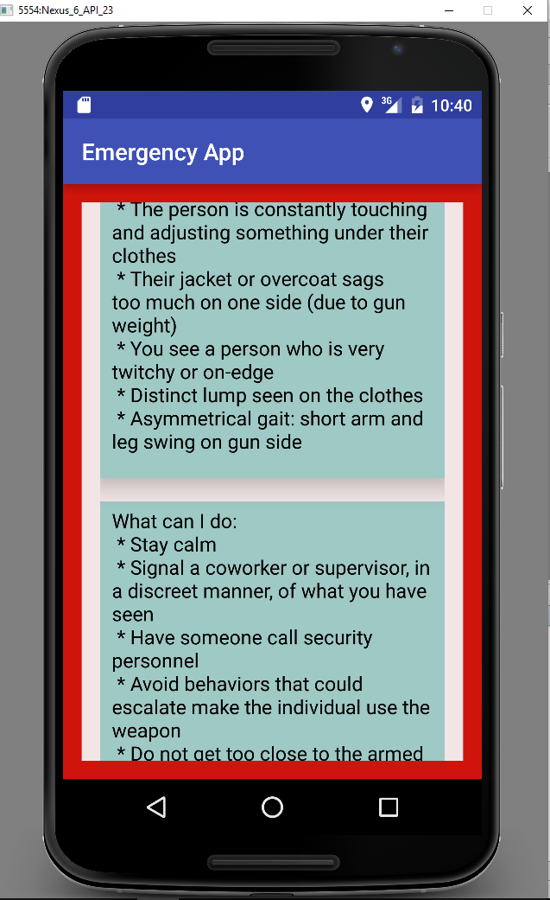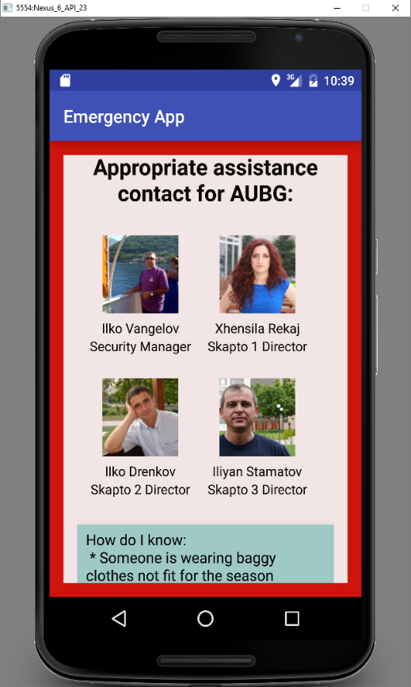

When weapon in campus is pressed, it opens a view, very similar to violence one, for contacting with AUBG staff, security manager and directors of residences. A section “How do I know?” with explanation for knowing if you are witnessing someone with a weapon. And it also shows possible suggestions of ways to monitor, assist and diffuse the situation until help arrives.

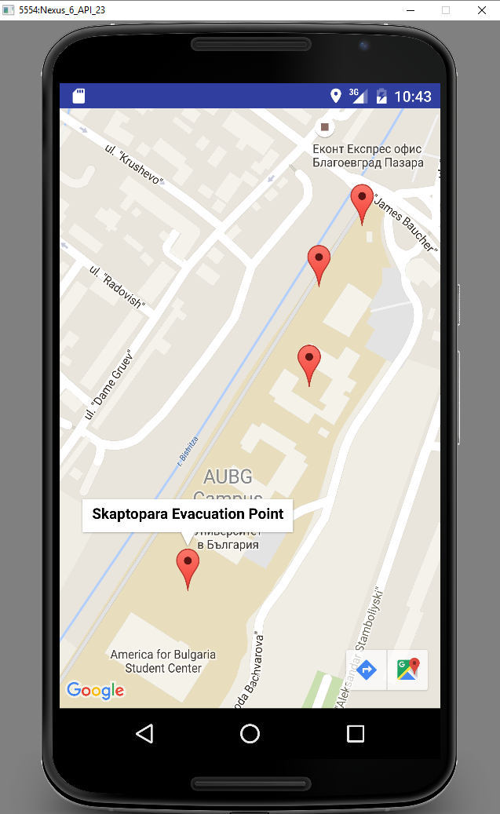

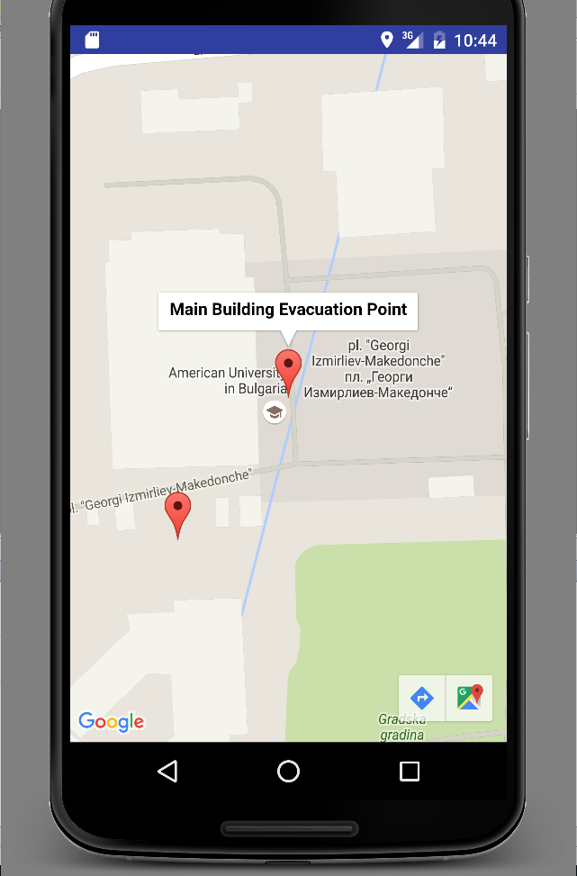

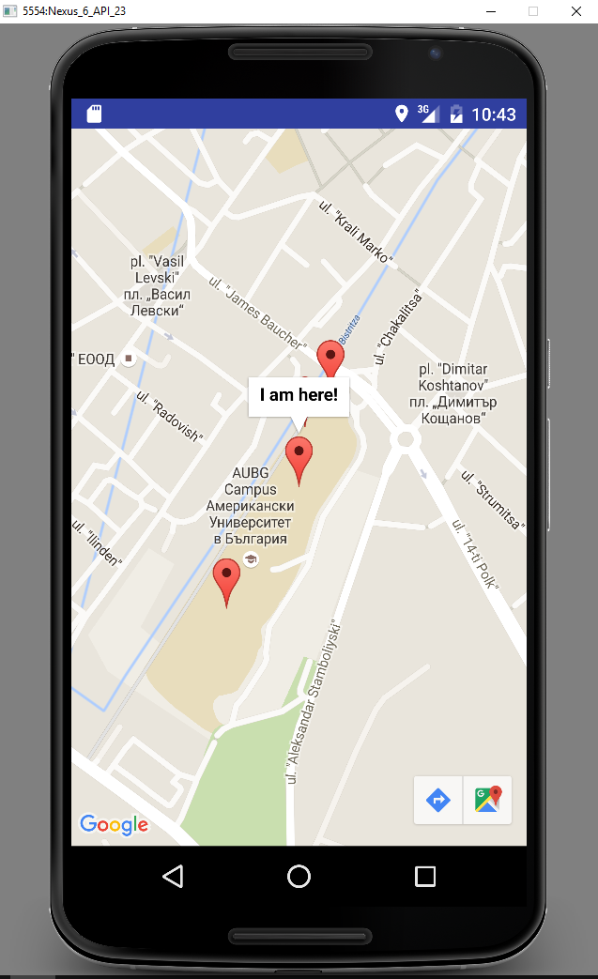

When pressed Campus Emergency Map, a map activity is launched. In it we can see evacuation point in main building and in campus. We also can see our position in the map in order to know how to go to the closest evacuation point.

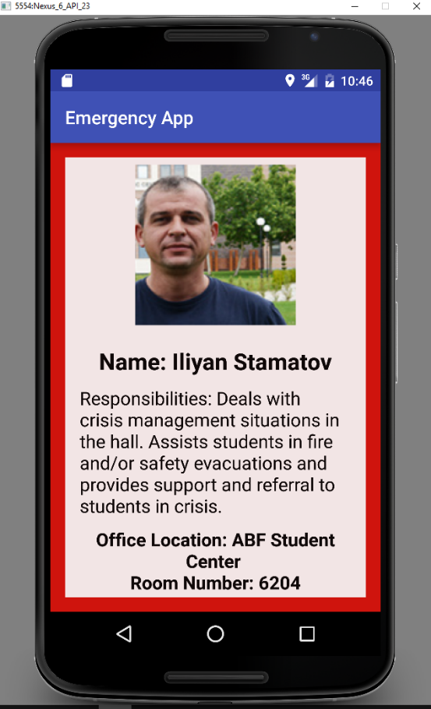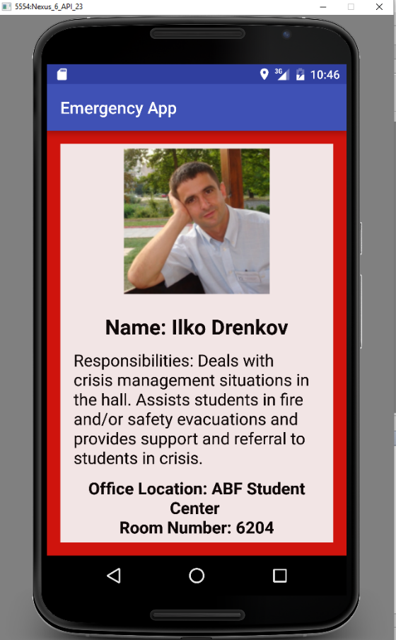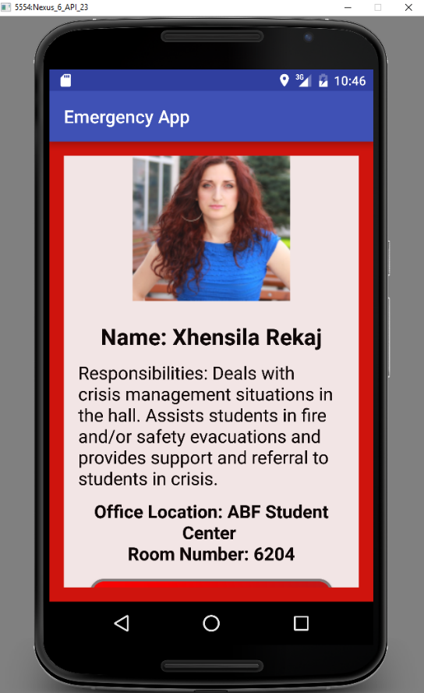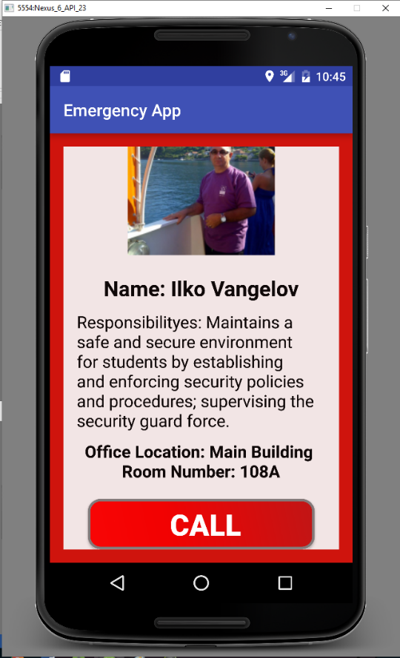

When, in violence and weapon activities, the image of one of the staff is pressed, a view with some detailed information appears. We can see a bigger photo, name and his/her responsibilities. Information about where to find them and a button for calling them directly. Skapto 2 Director has no button because there is no phone number we could find.

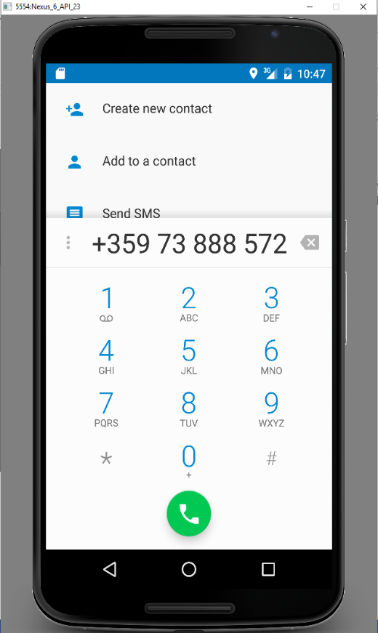

When the call button is tapped, the default phone application is launched with the appropriate phone number already dialed.